3D Weather in the Classroom

***Inter-Tropical Convergence Zone***

1. **Overview**

The Intertropical Convergence Zone (ITCZ) is recognized as a line of thunderstorms running around the Earth near the equator where the trade winds collide (Figure 1). This collision of winds along with high moisture content in the air and relatively high sea surface temperatures in the tropical region of the equator causes the ITCZ to form.

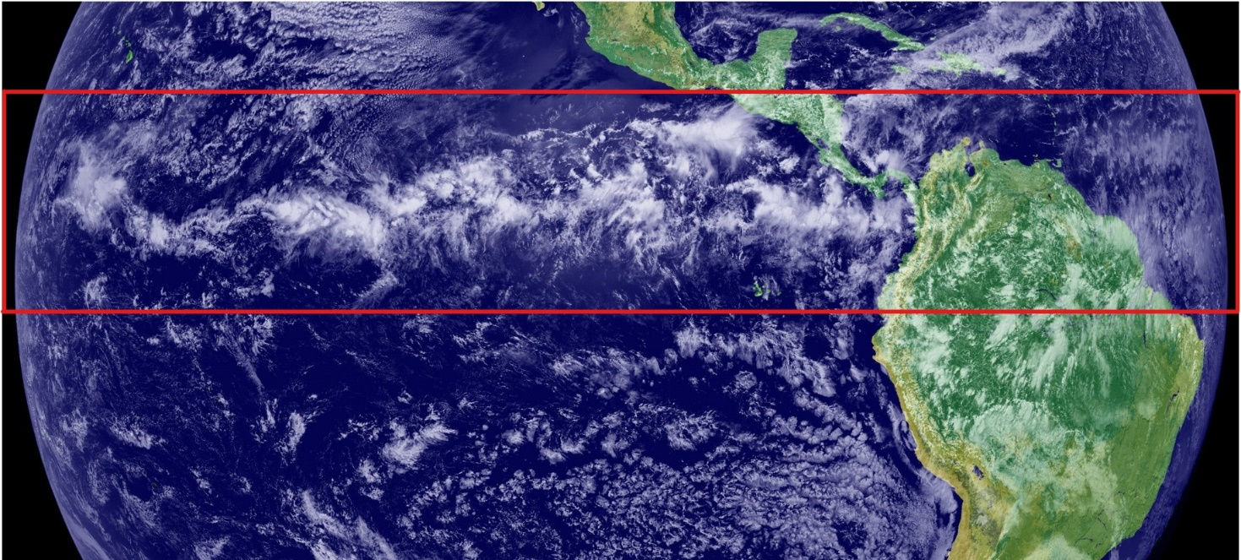

*Figure 1. Visual Satellite Imagery of the ITCZ shown as a line of thunderstorms near the equator.*

The ITCZ forms the center of the Hadley Circulation, one of the primary global circulation cells. High sea surface temperatures and convergence of the trade winds cause the air to rise to the top of the troposphere or to the tropopause. From the tropopause, the air can’t rise any further, so it distributes towards the North Pole or South Pole into the mid-latitudes. Thus, creating the Hadley Circulation (Figure 2).

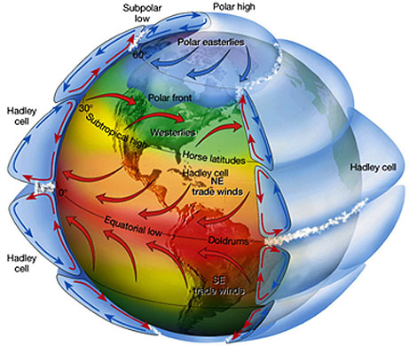

*Figure 2. The center two cells show the Hadley circulation because of the equatorial low.*

The Trade Winds (a wind that blows steadily towards the equator from the northeast in the northern hemisphere or southeast in the southern hemisphere) flow as a result of the Thermal Low. The Thermal Low refers to low pressure associated with the high temperature air adjacent to the surface near the equator. The winds will flow from a higher pressure towards a lower pressure or Thermal Low.

Combined with the Coriolis Force (an apparent force that is the result of the earth’s rotation, deflects moving objects to the right in the northern hemisphere and to the left in the southern hemisphere) the change in wind direction from the mid-latitudes towards the tropics leads to easterly flow (from the east) in the Trade Winds.

The weather patterns for this day show the convergence of the winds near the surface, corresponding to where the Trade Winds come together at the base of the Hadley Cell (Figure 3). This is most apparent in the eastern Pacific Ocean, which is also where the clouds from the ITCZ are clearly visible.

*Figure 3. Snapshot of the IDV 3D imagery project where the streamlines showing northeasterly wind flow in the northern hemisphere and southeasterly wind flow from the southern hemisphere converging near the equator.*

The ITCZ shifts seasonally based on sun angle and the distribution of land and water at specific latitudes. As a result, there is usually some north-south variation in the location and strength of the ITCZ across the globe. Typically, the ITCZ resides north of the equator in the northern hemisphere summer and south of the equator in the southern hemisphere summer.

This can lead to defined wet and dry seasons in the tropics, which is most apparent over Africa (Figure 4a), South America, and Southeast Asia where the seasonal shifts in the location of the ITCZ influences rainfall and cloudiness (Figure 4b).

*Figure 4. Explains (a) the air mass types relative to the ITCZ’s location over Africa and (b) the effects of the warm and dry conditions of north Africa due to the Tropical Continental (cT) airmass.*

The ITCZ is best seen using satellite imagery and can be recognized by a line of thunderstorms along a line roughly parallel to the equator. The image below from November 8, 2021, taken by the Geostationary Operational Environmental Satellite (GOES; [GOES Imagery Viewer - NOAA / NESDIS / STAR](https://www.star.nesdis.noaa.gov/GOES/index.php)), show the ITCZ just north of the equator.

This flow pattern is associated with the highest temperatures being near the equator at this time of year, leading to the development of the thermal low and the converging winds associated with the ITCZ (Figure 5).

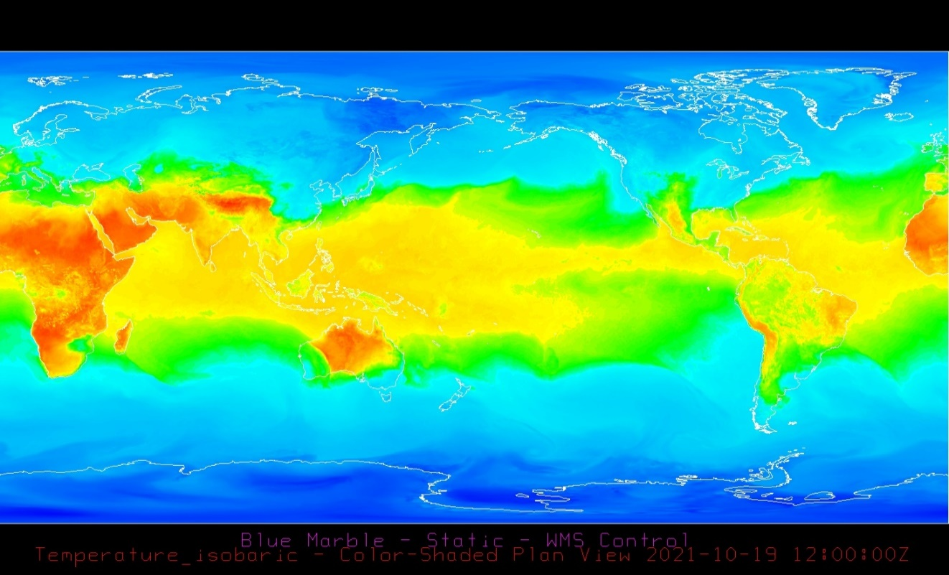

*Figure 5. IDV 3D imagery displaying sea surface temperatures.*

1. **IDV Project**

* Project filename: “ITCZ.xidv”
* Project data:
  + Filename: “gfs.t12z.pgrb2.0p25.grb2”
  + 0.25°x0.25° Global Forecast System (GFS) analysis data for Oct. 19, 2021 @ 12:00Z.
  + File retrieved from NOAA operational model page for select levels and variables:
    - [NOMADS-NOAA Operational Model Archive and Distribution System](https://nomads.ncep.noaa.gov/)
* Displays:
  + Maps
    - Blue Marble (underlay)
    - World country outlines.
  + Plan views
    - 1000 mb temperature (°C)
  + Flow displays
    - 1000 mb streamlines
* Features to note:
  + Figure 3. Winds converge near the equator due to the thermal low formed by the high surface temperatures. This convergence is the ITCZ.
  + Figure 5. Surface temperatures across the globe are highest in the Tropics (Hadley Cell) and the lowest in the Arctic (Arctic Cell), with the strongest temperature gradients in the mid-latitudes (Ferrell Cell).
    - This is most evident in the plan view of 1000 mb temperature.

1. **Knowledge Requirements**

* Module 1.1 Global Temperature Pattens
* Module 2.2 Pressure and Wind at Different Atmospheric Levels

1. **Knowledge Test**
2. What is the ITCZ
3. The Inter transitional Cloudy Zone
4. **The intertropical Convergence Zone**
5. The Intertropical Zone of Clouds
6. The zone of tropical weather
7. The ITCZ is recognized as a line of thunderstorms running around the Earth near the equator where the _____ winds collide.
8. **Trade winds**
9. Westerlies
10. Temperature
11. Strong
12. What are the trade winds?
13. **Easterly winds from both the northern and southern hemisphere that converge near the equator.**
14. Westerly winds in the northern hemisphere and easterly winds in the southern hemisphere that converge near the equator.
15. Westerly winds from both the northern and southern hemisphere that converge near the equator.
16. Easterly winds in the northern hemisphere and Westerly winds in the southern hemisphere that converge near the equator.
17. Does the ITCZ shift seasonally>
18. **Yes**
19. No
20. What is Coriolis force?
21. **an apparent force that is the result of the earth’s rotation, deflects moving objects to the right in the northern hemisphere and to the left in the southern hemisphere**
22. an apparent force that is the result of the earth’s rotation, deflects moving objects to the left in the northern hemisphere and to the right in the southern hemisphere
23. an apparent force that is the result of the earth’s rotation, deflects moving objects to the east in the northern hemisphere and to the west in the southern hemisphere
24. an apparent force that is the result of the earth’s rotation, deflects moving objects to the north in the northern hemisphere and to the south in the southern hemisphere
25. The ITCZ forms the center of the _________ Circulation.
26. **Hadley**
27. Ferrel
28. Artic
29. Polar
30. What is the Thermal Low?
31. **Refers to low pressure associated with the high temperature air adjacent to the surface near the equator.**
32. Refers to high pressure associated with the low temperature air adjacent to the surface near the equator.
33. Refers to low pressure associated with the low temperature air adjacent to the surface near the equator.